Best astrologer in world - Astrologyexperts

No depend how tons the world speaks that they recognize the entirety about them and the solutions they are seeking for in their lives in the great feasible manners, absolutely everyone is conscious how challenging or difficult it is, in reality, to absolutely understand our personal selves. It is no comic story nowadays when humans go via so a whole lot in their lifetimes and, in the process, occasionally additionally have to provide up in the middle, questioning they can't reap what they want in life. But, at last, existence isn’t as terrible as humans regularly suppose it is, and who higher than the great astrologer in India and even in the world than Jyotish Acharya Devraj JI to emphasize on the same?
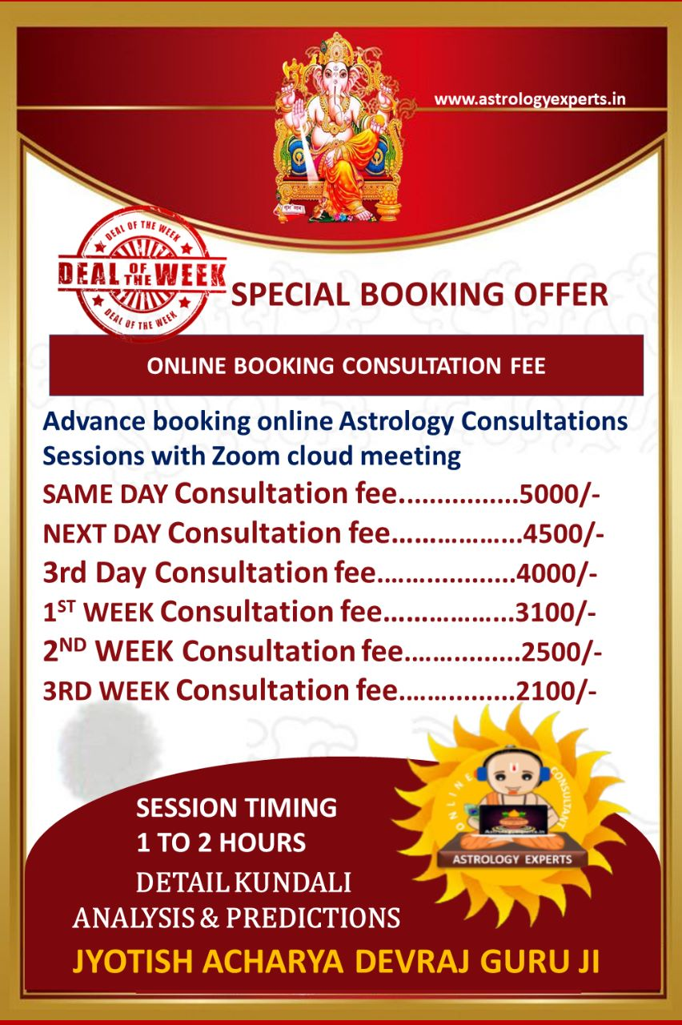
Jyotish Acharya Devraj JI is no longer known as the Vedic Science specialist and best astrologer in world for nothing. He serves as one of the ideal astrologers in the world for all the proper reasons. There have been human beings and followers who have ardently sought his training over the years to get via existence and to obtain the proper type of insights they usually desired to recognize to higher their journeys in existence and career. The well-recognized Mystic, Spiritual and Yogic Guru is all what human beings would ever choose in their lives as he in no way shies from speakme the fact to them and assisting them get one-on-one with the difficult records of existence whilst making positive to assist them overcome all these hurdles and struggles on their course like a actual buddy and guide.

Excelling at distinctive offerings like Vedic Astrology, Palmistry, Face Reading, Nadi Astrology, Gemmology, Horoscope highly skilled in KP, Jyotish, Nadi Jyotish, and Numerology. He specializes in scientific, technical, logical analysis of your Janam Kundli, and gives the most accurate diagnosis studying and matching, Tarot Reading, and a whole lot more, Jyotish Acharya Devraj JI showcases how he can clearly make a distinction in the lives of others and make it all seem to be effortless.

Jyotish Acharya Devraj JI Contact details: (Phone/WhatsApp number) +91 9355355059, 9355355025

