Hair Products For Oily Hairs

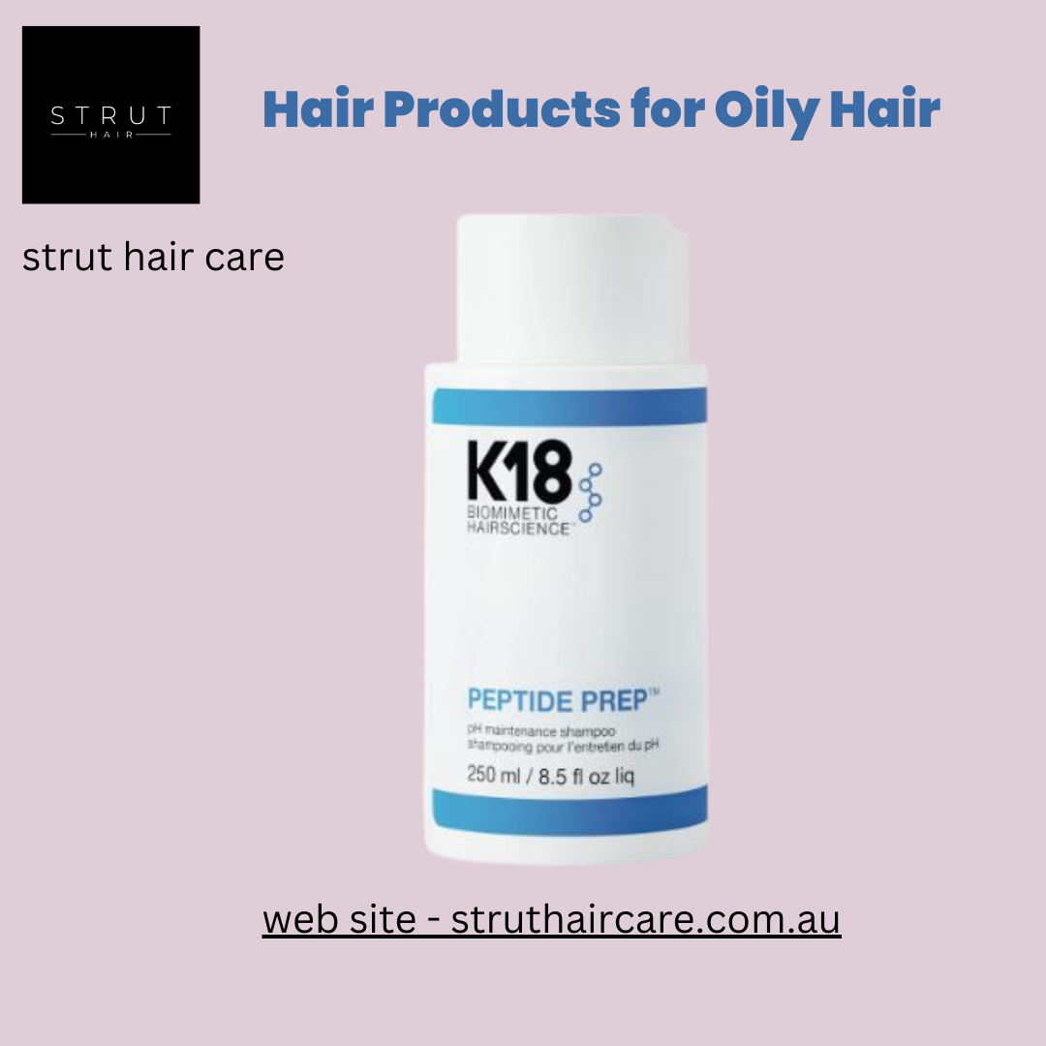
As we all know, maintaining a diet for our body is crucial as maintaining a diet for our hair also plays a vital role because hairs also deserve proper care and treatment. It also needs the best shampoos and conditions like our body needs quality food. Your hair may eventually cease growing if you don't take care of it. You could gradually begin to notice dryness, dullness, hair loss, and dandruff.
Ingrown hairs can result from extended durations without cleaning your hair. Yes, you heard it correctly, they may also appear on the scalp. You are also drawing additional dust to yourself if you leave your hair unwashed for an extended period of time. The incorrect hair care products can cause itching and cause hair loss. But We at Strut will make your hair oil-free without feeling any type of itching and flaking. Avoid shampoos and conditioners that have too much moisture.
Let’s try, shampoo and other Hair Products for oily hairs of strut it contains things like tea tree oil, salicylic acid, and many more. It will help you in cleaning of scalp, and it also controls sebum production. You can keep your hair shiny as well as healthy by using these shampoos and conditioners.
Our products for your Oily Hairs
Are you getting rid of with your oily hairs? Don’t worry, we at Strut are always ready to offer you products that will help you maintain your hair with smoothness. Oily hair can be a persistent challenge for many individuals, requiring a strategic approach to hair care.
Finding the right products tailored to control excess oil and maintain a fresh, vibrant look is crucial. In this guide, we explore a range of effective hair products specifically designed for oily hair types, offering solutions to help you achieve the luscious locks you desire.
Shampoos- One of the key weapons in the battle against oily hair is a high-quality clarifying shampoo. We have a wide range of Hair Products for oily hairs but here there are some shampoos that will help you to keep your hairs oil free and more shinny. Including, K18 Peptide pH maintenance Shampoo, Pure Volume Shampoo, Oily Hair Hydrate Sheer Shampoo, Detox Hair Cleansing Cream, Head Muk Oily Scalp Shampoo Volume Injection Shampoo.
Conditioners- In addition to its basic purpose of cleansing the scalp's skin and hair, a conditioner also serves to condition and beautify hair and functions as a support system for the treatment of a variety of scalp problems. Volumizing shampoos and conditioners are ideal for individuals with oily hair who seek to add body and lift without weighing down their locks. These products help create volume at the roots, preventing that flat, greasy appearance. Choose formulas that provide a lightweight boost for a fresh and bouncy feel.
Our conditioners are- Pure Volume Conditioner, Volume Senses Amplifying Conditioner, Hydrate Sheer Conditioner, Volume Injection Conditioner, and many more.

About us
William, the proprietor of Strut Hair & Make Up, founded Trut Hair Care. With over 12 years of experience in the salon, he is a gifted and imaginative hairstylist and the proprietor of his own salon. William is proficient in all facets of industry developments and possesses excellent understanding of them. He has a strong desire to help his customers look and feel their best. He also knows a lot about hair products and can provide direction and advise.
William has entered the world of online hair products. In 2021, he made the decision to create the website so that his clients could get the highest-quods at the most competitive rates without having to return to the saality golon in between appointments. u can regain control over oily hair and boost your confidence with healthy, fresh-looking locks. Experiment with different Hair Products for oily hairs to find the perfect combination for your unique hair type, and say goodbye to greasy hair woes. If you are to make your hairs more shinny and oil-free you can buy any product from our site.

