Know about the Agroforestry in India
The Agroforestry in India, a land management practice fostering the coexistence of trees, crops, and animals on the same property, stands in stark contrast to monoculture farming by promoting the simultaneous growth of a variety of plants. This sustainable approach contributes to land diversity, prevents soil erosion, conserves water, and enhances soil fertility. In India, agroforestry is a longstanding tradition, encompassing various systems such as Alley Cropping, Silvopasture, Windbreaks and Shelterbelts, and Forest Farming.
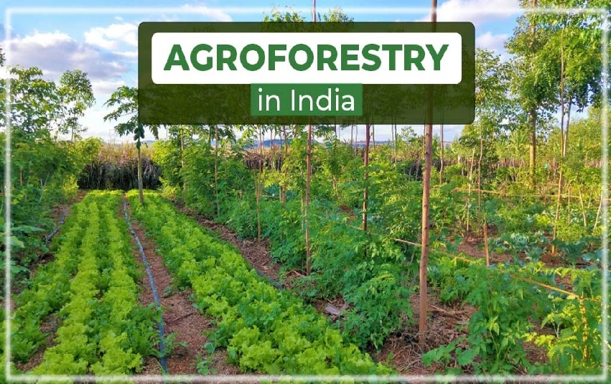
Types of Agroforestry-
- Alley Cropping: Nurturing Harmony in Rows Alley cropping creates a harmonious neighborhood for plants and trees. Rows of trees are planted alongside crops, forming paths where farming occurs. This arrangement provides shade for crops, prevents soil erosion, and creates an ideal environment for both trees and crops to flourish.
- Silvopasture: Where Trees, Grass, and Animals Unite Silvopasture represents a natural alliance where trees, grass, and animals collaborate. Trees provide shade for animals while they graze, ensuring their comfort. This symbiotic relationship supports the health of both the grass and the animals, with trees offering timber, shade, and forage.
- Windbreaks and Shelterbelts: Nature's Protective Embrace Acting as natural defenders, windbreaks and shelterbelts consist of rows of trees encircling fields to shield crops from strong winds. This not only prevents soil erosion but also enhances microclimate conditions, benefiting both crops and animals.
- Forest Farming: Crops Under Nature's Canopy Forest farming involves cultivating valuable crops within a managed forest. By leveraging the natural shade and biodiversity of the forest, this method provides an ideal environment for crops to thrive, presenting a unique and sustainable farming approach.
Benefits of Agroforestry
Agroforestry offers a holistic approach with various benefits for farmers:
- Enhanced Biodiversity: Agroforestry transforms farms into diverse ecosystems, fostering habitats for microorganisms, insects, and birds. This biodiversity acts as a natural pest control, reducing the need for chemical interventions and enhancing overall resilience.
- Improved Soil Health: Trees act as protectors of the soil, preventing erosion and enriching it with organic matter. Leaves from trees create a natural blanket on the ground, enhancing soil fertility and strength.
- Climate Change Mitigation: Agroforestry plays a crucial role in mitigating climate change by sequestering carbon through tree photosynthesis, helping reduce the impact of greenhouse gases.
- Sustainable Water Management: The strategic placement of trees aids in efficient water management, reducing runoff, improving groundwater recharge, and maintaining optimal soil moisture levels, particularly beneficial in water-scarce regions.
- Economic Diversification: Agroforestry transforms farms into multifunctional landscapes, providing economic benefits beyond traditional crops, including fruits, nuts, timber, and medicinal plants. This diversification makes farmers less vulnerable to market fluctuations.
- Resistance to Climate Variability: The diverse structure of agroforestry systems enhances resilience to climate variability, offering a stable and reliable agricultural production system. This resistance mitigates the impact of extreme weather events.
agroforestry represents a sustainable and environmentally friendly farming method that addresses challenges such as climate change and food security while ensuring a better quality of life for people. TractorKarvan, as a distinguished online platform, offers top-quality used tractors at competitive prices, streamlining the tractor-buying experience for customers and contributing to the modernization of Indian agriculture.

