NDIS Disability Care Melbourne | Dreams Alive Care
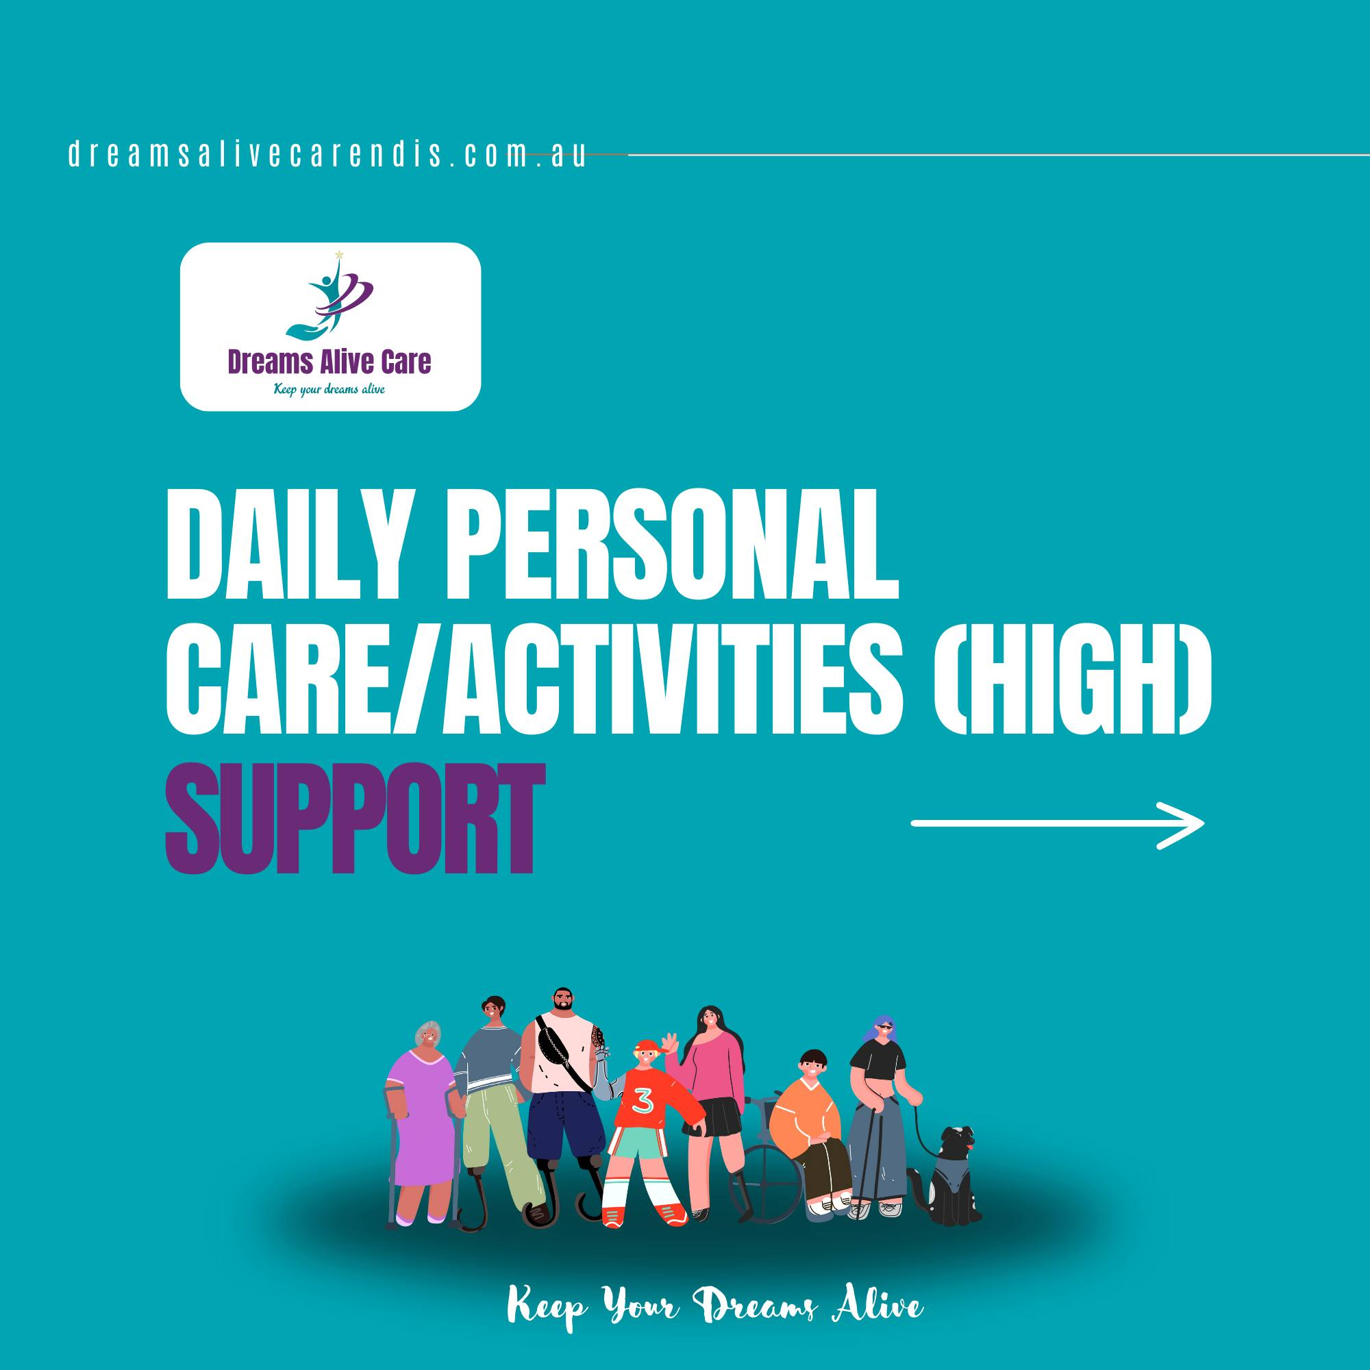
For those with impairments, the NDIS disability care Melbourne is a life-changing program. The NDIS helps to foster an environment that is more inclusive and supportive by placing a high priority on customized care, empowerment, and community participation. The concepts of choice and control are given top priority in Melbourne's NDIS disability care. It is up to the participants to decide for themselves whose service providers, support staff, and kind of help they get. Our goal is always to offer services that are personalized and have the highest calibre. We at Dreams Alive Care are committed to offering our customers services with the whole freedom to pursue their aspirations as well as lead satisfying, healthy, and happy lives, regardless of whether they have complicated or straightforward demands.
A wide range of support services, such as personal care, therapy, community access, assistive technology, and home adaptations, are provided by Melbourne's NDIS. This all-encompassing strategy seeks to improve participants' general well-being while attending to their diverse requirements. The NDIS Disability Care Melbourne is a revolutionary program that helps to empower people with disabilities as well as provides personalized assistance and tools to enable them to live life on their terms. An extra thank you to everyone from our participants' varied and ethnic backgrounds—your individual touch brought vibrancy to the event! Together, let us continue to appreciate the beauty of variety. Dreams Alive Care welcomes all guests.
Services
the NDIS helps to establish a more welcoming and encouraging atmosphere. Melbourne's continued adherence to the NDIS's tenets will undoubtedly have a significant and beneficial influence on the lives of people with disabilities, demonstrating a dedication to their dignity, autonomy, and improved quality of life. Having worked with people who are suffering from disabilities for many years, our team of experts is well-versed in maximizing the benefits of your NDIS plan. NDIS disability care Melbourne actively promotes social inclusion and community involvement. Our multicultural team works to create an individualized plan that best meets the needs of each participant, assisting them in becoming independent and achieving their objectives. Here are some services that we offer at Dreams Alive Care.
1. RESPITE CARE
2. HOUSEHOLD TASKS ASSISTANCE WITH TRAVEL/TRANSPORT
3. COMMUNITY NURSING
4. DAILY PERSONAL ACTIVITIES
5. COMMUNITY ACCESS
6. COMMUNITY PARTICIPATION
7. DEVELOPMENT OF DAILY LIVING SKILLS
8. GROUP/CENTRE BASED ACTIVITIES
9. PERSONAL CARE
10. DAILY PERSONAL CARE/ACTIVITIES (HIGH)
With years of expertise, our team of professionals is dedicated to providing a comprehensive range of services. The NDIS disability care Melbourne seeks to improve a person's life in several ways, including more mobility, social ties, and independence. We can assist you in locating the best service providers, put you in touch with local resources, and even provide your family members training so they will be prepared to look after you.
Why us?
The provision of specialized support services is one of the main characteristics of NDIS Disability Care in Melbourne. Together with their support coordinators, participants create personalized plans that are tailored to their unique requirements, objectives, and aspirations. The use of a person-cantered approach guarantees that the assistance provided is not only efficient but also tailored to the individual's specific needs. With a wide range of programs geared toward those with physical, mental, and intellectual challenges, we pursue your aspirations. Your dreams are your life objectives, and we are here to help you realize them.
Our goal is to establish an atmosphere of open communication, respect, and trust. In addition, we want to foster an atmosphere where individuals are valued, listened to, and understood. We intend to provide a warm and supportive environment that will aid in people's skill development by skillfully using a caring approach. The NDIS disability care Melbourne places a lot of focus on social inclusion and community involvement in addition to individual support. To build relationships and a sense of belonging, participants are urged to actively participate in social groups, events, and community activities. That’s the reason we are available 24/7 and committed to offering high-quality services with our knowledgeable and skilled team.

