Self-Adhesive Labels Market: The Future of Packaging, Business Overview
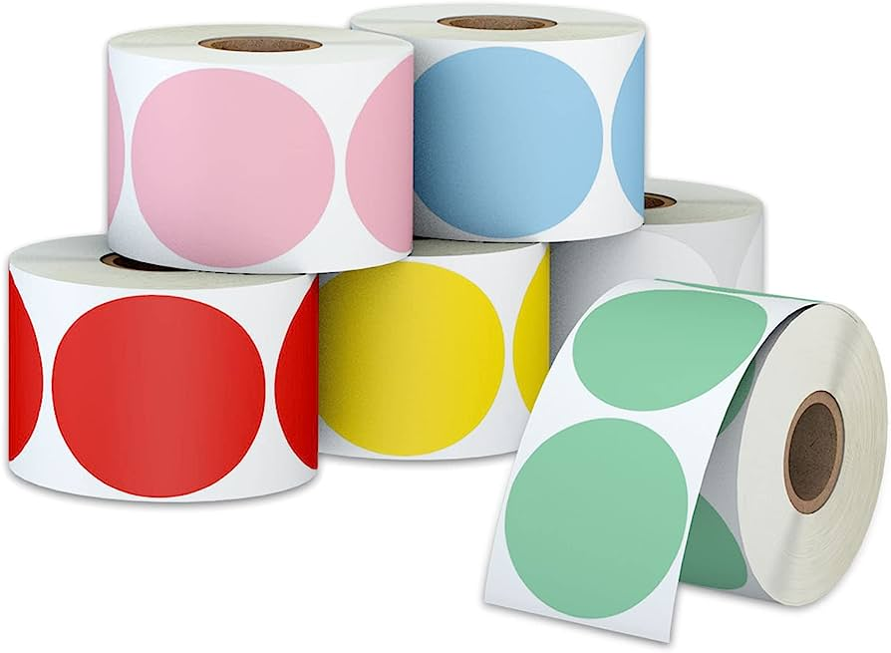
Self-adhesive labels, also known as pressure-sensitive labels, are a popular type of packaging label that can be applied to a variety of surfaces, including plastic, glass, and metal. These labels use a special adhesive that allows them to stick to the surface of the packaging without the need for heat or solvent activation. Self-adhesive labels offer several benefits, including versatility, durability, and cost-effectiveness.
The global self-adhesive labels market size is projected to reach USD 64.9 billion by 2028 from USD 42.9 billion in 2021, exhibiting a CAGR of 6.1% during the forecast period.
Versatility

Self-adhesive labels are highly versatile and can be used for a wide range of packaging applications, including food and beverage packaging, pharmaceuticals, cosmetics, and household products. They can be customized to meet the specific needs of a product and can be printed in a variety of colors, shapes, and sizes. Self-adhesive labels can also be used for promotional purposes, such as adding a QR code or promotional message to the label.

Durability

Self-adhesive labels are highly durable and can withstand a variety of environmental conditions, including moisture, heat, and cold. This makes them an ideal choice for packaging products that require a long shelf life or that are exposed to harsh environmental conditions during shipping and handling. Self-adhesive labels also resist fading and smudging, ensuring that the label remains legible and attractive throughout the life of the product.

Cost-Effectiveness

Self-adhesive labels are a cost-effective packaging solution, particularly for small and medium-sized businesses. They require minimal equipment and can be printed in-house or by a third-party printing company. This allows businesses to produce high-quality labels at a lower cost than other types of packaging labels, such as shrink wrap or heat-sealed labels.

Challenges and Opportunities

While self-adhesive labels offer many benefits, there are also some challenges that need to be addressed. One of the biggest challenges is ensuring that the labels are environmentally friendly. The adhesive used in self-adhesive labels is often made from petroleum-based materials, which can contribute to plastic pollution. However, there are now options for bio-based adhesives that are more sustainable.

Another challenge is ensuring that the labels are easy to remove and do not leave residue on the packaging. This is particularly important for recycling purposes, as any residue left on the packaging can contaminate the recycling process.

However, there are also opportunities for innovation and growth in the self-adhesive labels market. As demand for sustainable packaging solutions continues to grow, there will likely be an increase in investment and research in this area, leading to new and improved self-adhesive label options.

Conclusion

Self-adhesive labels are a versatile, durable, and cost-effective packaging solution that offer many benefits to businesses and consumers alike. While there are still challenges to be addressed, the opportunities for innovation and growth in the self-adhesive labels market make it a promising option for the future of packaging. By embracing sustainable materials and practices, we can ensure that self-adhesive labels remain a viable and environmentally friendly option for years to come.
Related Blogs-
Technical Textiles Market
Hydrogen Peroxide Market

