Revitalize Your Sex Life with Legal 4 Best Female Libido Boosters 2024 Reviews (Honest Customer Warning!) How To Increase Excitement In Female Instantly?
Best Female Libido Enhancement
Best Female Libido Boosters Pills
Best Female Libido Boosters
Best Female Libido Boosters is a pill for women that claims to increase sexual strength and stamina by balancing out hormones and body chemistry. It claims to have been endorsed by doctors, and to be all-normal.
Every pill contains removes, mainly from spices, that should make the right balance in the body for optimal sexual desire. One of its focuses is to increase normal lubrication, so women feel more confident going into sex. There are numerous other auxiliary effects this item should have, including less emotional episodes, more energy, and less hot flashes for women who are going through perimenopause. The company that makes this item promises that it contains no side effects by any means, which is quite a claim.
For women whose libido has been hampered by menopause, stress, or even a characteristic chemical imbalance, the supplement we recommend is a pill called Libitrinex. Each container is specially formulated with regular home grown concentrates to improve hormonal result, advance excitement, and give women more pleasure during sex.
Click Here To Get Best Female Libido Boosters For An Exclusive Discounted Price
Best Female Libido Boosters INGREDIENTS AND SIDE EFFECTS
L-Arginine: A compound usually found in food sources like dairy and wheat, it has the ability to help great cardiovascular wellbeing, and in the case of supplements like Best Female Libido Boosters, to help blood stream to the genitals. It does this by converting into nitric oxide in the blood, which can widen veins.
Dark Cohosh: In traditional Native American medicine this plant was used as a medicine for treating issues with menstrual wellbeing, including menses and menopause. It evidently does this by regulating hormones, and can consequently meaningfully affect the sex drive.
Damiana: A plant that fills in a few pieces of Focal America, the concentrate of this spice is used in traditional medicine as a method of increasing sexual desire in women and men.
Kudzu: This is a vine whose concentrate has been used in traditional Chinese medicine to treat various different symptoms, including issues with circulation, the stomach, dizziness, and nausea. There is "insufficient evidence" for these claims, however, and there are possible side effects of ingesting kudzu root, including:
Liver damage, allergic reactions
Ginseng: A spice native to parts of Korea and China, it has been used in traditional medicine as a method for stimulating sexual excitement in men and women, and has been used to increase performance and physical stamina in competitors as well.
Valerian: This plant is used as a characteristic muscle relaxant, which can help individuals rest better and can lessen cramps.
Ginkgo Biloba: This tree is mainly tracked down in pieces of Asia, and is used to make normal remedies for sexual performance issues. It is additionally used to improve circulatory function.
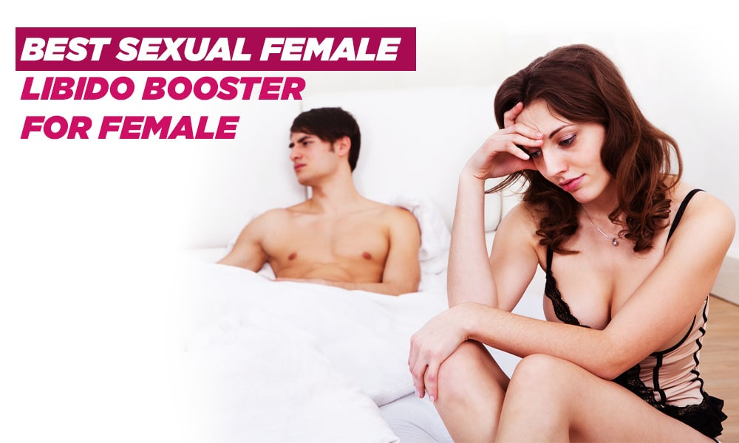
Best Female Libido Boosters QUALITY OF INGREDIENTS
Best Female Libido Boosters has an enormous list of ingredients that should all contribute to better sexual wellbeing, including a lot of vitamins and minerals that are particularly useful to women. Some of the ingredients are great, and the company claims that they are obtained from the same GMP-certified sources that are used for supplements made by bigger companies like Rite Aid, Albertsons, and Safeway.
The inclusion of kudzu root could be a bit of an issue, in spite of some of these other ingredients. Kudzu is not demonstrated in any kind of clinical trials to work to improve circulation - apparently it's meant to provide blood stream to the genitalia - and there are some quite horrendous side effects associated with its use. Like many ingredients used in traditional Chinese medicine, its benefits are based on tradition and superstition, and little else.
Click Here To Get Best Female Libido Boosters For An Exclusive Discounted Price
THE PRICE AND QUALITY OF Best Female Libido Boosters
Best Female Libido Boosters is available on the company's main site, where it sells for $69.94 per bottle. On Amazon it can be purchased for $90 for a multi day supply.
Every container has 30 tablets, so if the proposed dosage is followed each jug should last close to a month. The company claims that individuals don't actually begin to see the promised effects until about a month in the wake of starting to take them, however, so this means that individuals will be supposed to purchase no less than two containers before they see whether it works or not.
In spite of the quality of the ingredients that the item claims, the item is fairly expensive except if purchased in mass, so for women trying it for the first time, they might need to spend a ton front and center despite paying less per-bottle - yet that discount possibly truly counts if the item works for you. Otherwise, the expenses truly add up.

CONCLUSION - DOES Best Female Libido Boosters WORK?
Best Female Libido Boosters has a ton of ingredients, and it's obvious that they are throwing everything into this formula with the expectation that it will be more impressive than another item that has less. In any case, in the end, there are some questions as to the efficacy of some of their ingredients - especially kudzu root - and customers report that it doesn't smell or taste particularly great. In addition, the company that makes it has a bit of an image issue, with heaps of negative customer reviews for their customer service, and practically no positive ones to balance things out. The company would do well to attempt to fix this, otherwise it would continue to be a turnoff to customers.
In the end, this item is an expensive version of what other supplements offer, and with the heaps of negative reviews about how it doesn't work, women considering this ought to think twice about risking their cash on this supplement.
There's another item we can recommend that promises to make no side impacts and comes with a guarantee of quality, and that item is Libitrinex. It's formulated out of every single normal ingredient and is designed to improve feminine reproductive wellbeing, energy and sexual power. Not just that, it can likewise help to treat the symptoms of menopause and PMS. Best of all, customers have glowing reviews about how it's helped improve their sexual lives.
Official Website https://www.onlymyhealth.com/best-female-libido-boosters-and-sexual-enhancement-pills-for-women-1706632713
https://www.facebook.com/BestFemaleLibidoBoosters/
https://www.facebook.com/FemaleLibidoBoostersPills/
https://best-sexual-enhancement-pills-for-women.jimdosite.com/
https://sites.google.com/view/best-female-libido-boosters/
https://worldhealthcarewebsite.blogspot.com/2024/03/BestFemaleSexualEnhancementPills.html
https://medium.com/@femalelibido/female-libido-boosters-instant-female-arousal-pills-over-the-counter-walgreens-us-2024-53b1b6df6f50
https://medium.com/@femalelibido/best-female-libido-boosters-pills-instant-female-arousal-drops-%EF%B8%8Fdoes-it-work-0af688d9afef
https://medium.com/@femalelibido/female-sexual-enhancement-pills-natural-medication-to-help-woman-climax-us-2024-294c4432b30a
https://medium.com/@mamiegrimes/best-female-libido-boosters-best-sexual-enhancement-pills-for-women-cef5914b937e
https://medium.com/@teresthomason/fulfill-your-desires-the-latest-in-female-libido-boosters-best-4-and-sexual-enhancement-pills-e1873155bb44
https://medium.com/@joyeefoley/best-libido-boosters-for-women-natural-supplements-save-your-sex-life-in-2024-scam-or-legit-dc7211e416fa
https://medium.com/@bestfemalelibidobooster/4-things-to-know-about-best-female-libido-boosters-31-march-new-critical-customer-warning-alert-82a8274d91ed
https://best-instant-female-arousal-drops.company.site/
https://best-libido-boosters-for-women.company.site/
https://bestfemalesexualenhancementpil.godaddysites.com/
https://best-female-libido-boosters.webflow.io/
https://best-female-libido-boosters-2024-pills.webflow.io/
https://devfolio.co/projects/best-female-libido-boosters-2f33
https://devfolio.co/projects/best-female-libido-boosters-2f33
https://www.myrtlebeastocr.com/group/gear-accessories/discussion/e53e27ae-f6ca-49fb-a68f-05eea48ca273
https://www.myrtlebeastocr.com/group/gear-accessories/discussion/3d97e3d2-6021-46f2-b247-5c5ceb256370
https://www.myrtlebeastocr.com/group/gear-accessories/discussion/db2fbf66-6084-4973-8160-19b63c1ee084
https://ecosoft.microsoftcrmportals.com/en-US/forums/general-discussion/43ab80da-e0e8-ee11-a81c-000d3a3a9886
https://ecosoft.microsoftcrmportals.com/en-US/forums/general-discussion/8d3d4f8b-34eb-ee11-a81c-000d3a3a9886
https://ecosoft.microsoftcrmportals.com/en-US/forums/general-discussion/c91cae8a-46e9-ee11-a81c-000d3a3a9886
https://ecosoft.microsoftcrmportals.com/en-US/forums/general-discussion/870627fc-53eb-ee11-a81c-000d3a3a9886
https://fms.microsoftcrmportals.com/forums/general-discussion/562377a1-2eeb-ee11-a73d-0022485987e6
https://fms.microsoftcrmportals.com/forums/general-discussion/4c938dbd-44e9-ee11-a73d-0022485987e6
https://fms.microsoftcrmportals.com/forums/general-discussion/844275f5-d9e8-ee11-a73d-0022485987e6
https://paidforarticles.com/top-4-best-female-libido-boosters-2024-reviews-honest-customer-warning-enhance-womens-desire-779457
https://paidforarticles.com/how-female-sexual-enhancement-pills-boost-sex-drive-sexual-desire-in-women-with-natural-ingredient-779463
https://paidforarticles.com/how-to-increase-excitement-with-best-female-libido-boosters-in-female-body-instantly-779468
https://enavate.microsoftcrmportals.com/forums/general-discussion/008424b0-52eb-ee11-a73c-0022484d9402
https://enavate.microsoftcrmportals.com/forums/general-discussion/05c99351-56eb-ee11-a73c-0022484d9402
https://www.neunify.com/group/grupo-neunify/discussion/aab0b118-70b0-4227-8534-eba4b43074e1
https://www.theendhtx.com/group/the-end-community/discussion/65d1357a-e1a9-47ef-97b9-331b56376c05
https://www.eventogo.com/event/best-female-libido-boosters-2024-over-the-counter-medication-to-help-climax-female/
https://pdfhost.io/v/xduptUlHo_Legal_6_Best_Female_Libido_Boosters_2024_Reviews
Read More:
https://www.onlymyhealth.com/best-viagra-pills-for-woman-1706608270
https://www.onlymyhealth.com/best-supplement-for-muscle-building-legal-steroid-muscle-booster-1709139851
https://www.times-standard.com/2023/11/30/performer-8-reviews-official-2023-best-male-enhancement-testo-boost-pills-for-men/
https://www.theweek.in/focus/health-and-wellness/2024/02/14/best-male-enhancement-pills-2024-top-rated-over-the-counter-sex-erection-pills-that-actually-work.html
https://www.jpost.com/brandblend/article-791975
https://www.jpost.com/brandblend/article-789084
https://www.mid-day.com/lifestyle/infotainment/article/sugar-defender-reviews-and-complaints-2024-is-it-legit-does-it-really-work-23332083

